# Methodology

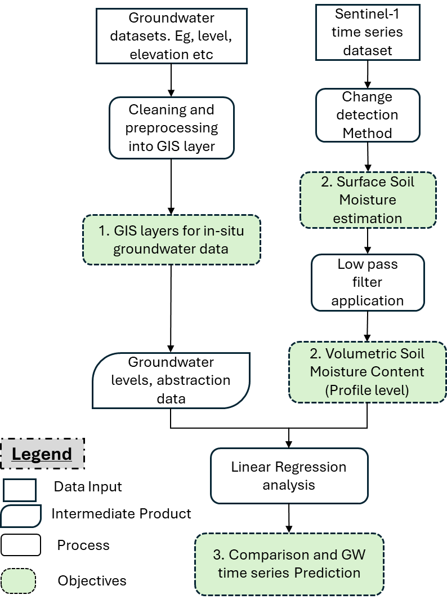

Figure 1: Methodology Flow Chart

### Change Detection and Soil Moisture Time Series Extraction

A linear scaling algorithm, change detection was used to inverse soil moisture time series from Sentinel-1 backscatter. The original method introduced by Wagner et al. (1999), is based on two main assumptions. First, the assumption is that all changes in the Sentinel-1 backscatter coefficient observations can be attributed to the changes in the soil moisture. The second assumption is that changes in soil moisture and changes in observed backscatter coefficients are linearly related to one another.

One advantage of change detection algorithm for soil moisture estimation is that it doesn’t require detailed ground information. The main approach of the algorithm is based on the scaling of minimum and maximum observed backscatter coefficients to the observed dry and wet conditions respectively. Equation 1 below provides an overview of the change detection model.

$rsi=\frac{s1_im-s1_min}{s1_max-s1_min}$ equation 1

Where rsi is the computed relative saturation index while s1_im is an incident Sentinel-1 backscatter. s1_min and s1_max are the minimum and maximum backscatter observations respectively. In this study 2.5 and 97.5 percentiles over the hydrological year were used instead of the absolute minimum and maximum backscatter as they can be outliers.

To generate volumetric soil moisture, the computed relative saturation index was linearly scaled to the soil moisture content at the welting and saturation point using equation 2 below:

$VSM=\left(SAT-WP\right)*(rsi+WP)$ equation 2

Where VSM is the volumetric soil moisture, while SAT and WP represent the soil moisture content during the soil saturated and welting points respectively. Soil hydrological properties were used to derive the SAT and WP information from BOFEK2020 soil dataset.

### Exponential Low Pass Filter

Mostly, time series of deep-water storage has been found to be less dynamic than surface and shallow water storage. In this study, the generated soil moisture time series was smoothened to match the groundwater dynamics. To achieve this, an Exponential low-pass filter method (ELPF) was used to delay soil moisture dynamics.

ELPF, first introduced by Wagner et al., (1999) is based on assumption that deeper water storage for this case groundwater is related to but less dynamic than top storage for this case surface soil moisture.

$VSWI=\frac{\sum_{i}{m_{s}(t_{i})e^{-(t-t_{i})/T}}}{\sum_{i}{e^{-(t-t_{i})/T}}} for t_{i}≤t$ equation 3

Where VSWI is the Volumetric Soil Water Index estimated at time index t using the remotely sensed soil moisture (VSM) at a time ti. T is the characteristic time length that accounts for depth and the pseudo diffusivity of water from top-most to the deep soil layer.

According to Wagner et al., (1999) the value of T can range from 1 to 100 days. In this study, the calibration process was conducted to obtain the best fitted T value with respect to groundwater level dynamics. A cross-correlation metric was used to determine the best T value. Finally, the best T value was used to compute VSWI.

### Groundwater level estimation

In this study, the linear relationship between soil moisture and groundwater was exploited to build a linear regression model that will interpret groundwater dynamics from VSWI (Time delayed Sentinel-1 VSM time series). Temporally matched and preprocessed time series of VSWI and groundwater level for the groundwater wells of interested were processed and used as the input of the univariate linear regression model. Equation 4 demonstrates the formulated linear regression model.

${Gw}_{i}= {VSWI}_{i}*X+C+∈_{i}$ equation 4

Where, Gwi and VSWIi represent the groundwater level and VSWI temporal matched incidences respectively. X and C represents slope and intercept coefficients of the linear equation respectively while and $∈_{i}$, represents the error term of the matched incidence.

Slope and intercept of the linear regression equation were estimated using ordinary least squares regression by minimizing the sum of squared differences between the observed and VSWI-predicted groundwater levels. Ordinary Least Squares (OLS) regression implemented through statsmodels in python was used for this task. Coefficient values that yield the minimum square errors were used to build a model to predict groundwater levels based on VSWI observations.

To evaluate the performance of the coefficients, accuracy metrics such as Pearson correlation score (r) and Root Mean Square Error (RMSE) were employed in this study. Correlation score informs about the direction and strength of the linear relationship if any while RMSE intel about the magnitude of the prediction deviation from observed ground water level. These metrics together provide a measure of the performance of linear regression and Sentinel-1 VSWI time series to interpret groundwater dynamics.

Pearson correlation (r) was computed using equation 5 below:

$r=\frac{n\sum{XY}-\sum{Y}\sum{X}}{\sqrt{{[n\sum{X^{2}-\left(\sum{X}\right)}}^{2}]{[n\sum{Y^{2}-(\sum{Y)}}}^{2}]}}$ equation 5

Where X and Y are respective VSWI and groundwater level incidences. n represents the total number of observations.

RMSE was computed using equation 6 below:

$RMSE=\sqrt{\frac{\sum_{i=1}^{n}{{(Y_{i}-Ý_{i})}^{2}}}{n}}$ equation 6

Where, $X$ and $Y$ represent the respective predicted and reference groundwater level or VSWI incidences.

Additionally, the significance of the slope coefficients was assessed using t-statistics and p-values. The t-statistic was computed as the ratio of the slope coefficient to the standard error of slope, while the p-value indicates the probability of observing a t-statistic as extreme as the one computed from the data, assuming that there is no detected relationship between groundwater and VSWI, the dependent and independent variables respectively. A low t-statistics value compared to the p-value (< 0.05) was used to classify a statistically significant regression coefficient, hence concluding a meaningful relationship between VSWI and groundwater levels.